Grid Voltage Fault

Author：胡心怡
Reviewer：Eason
FAQ/ Hybrid INV
Issue introduction
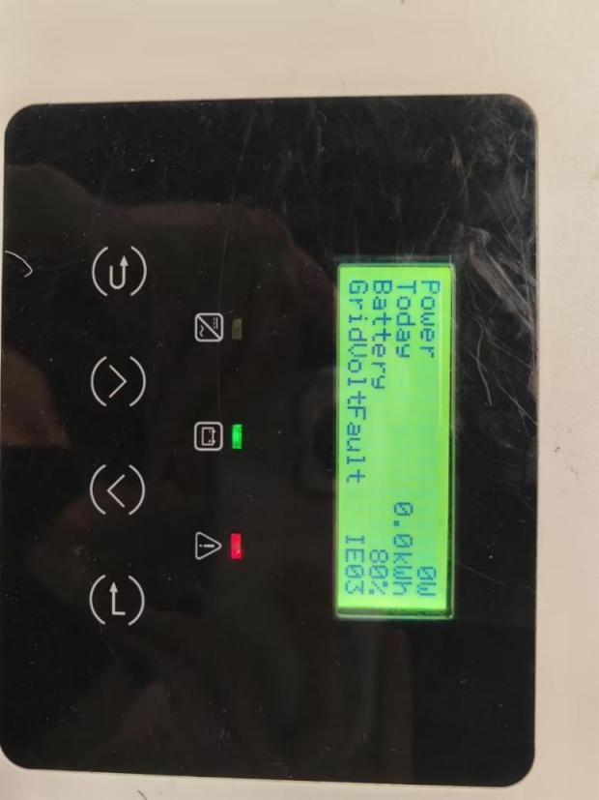
The inverter screen displays:GridVoltFault IE03.
Confirmation of basic information
[Photo] SN numbers of inverters.
Guidance for installer
Step1: Use a multimeter to measure the voltage at the inverter's AC port. In a three-phase system, measure the line voltage.
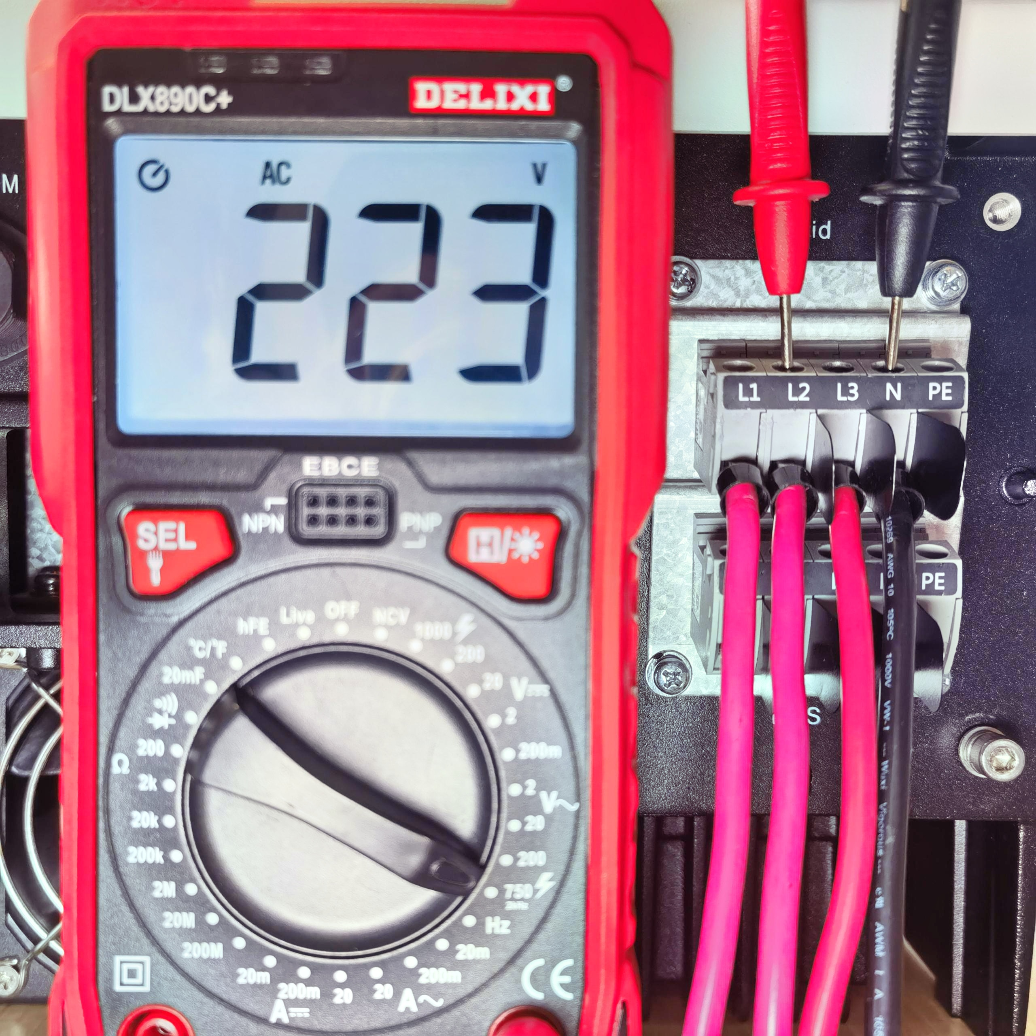 | 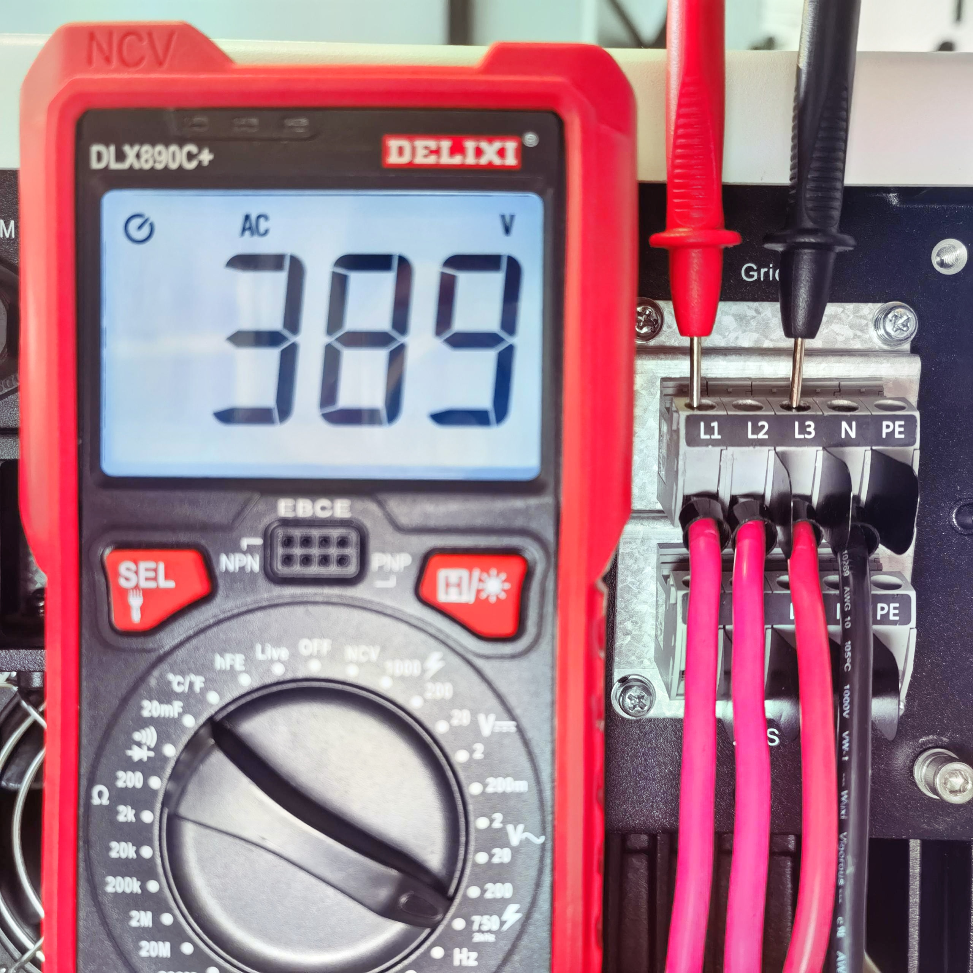
Phase voltage on the grid side | Line voltage(line voltage＝√3×Phase voltage)
Step2: Select the correct safety code.
Settings path:Advance setting→Safety
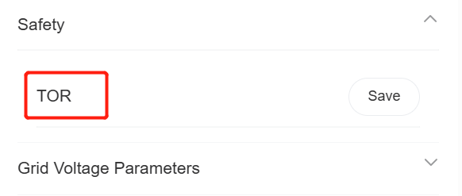
Step3: If none of the above solutions can solve the problem,adjust up grid protection voltage value by 5V
Settings path:Advance setting→Grid Voltage Parameters→OverVoltage_L1(V)
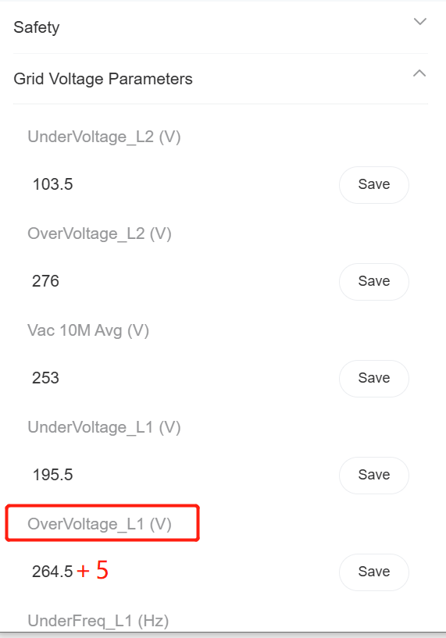
Information check list
If you have completed the above <Guidance for installer>, and the problem is still not solved, please collect the following troubleshooting information and send them to the R&D.
1. [Photo]SN number of the inverter, which should clearly display the registration number.
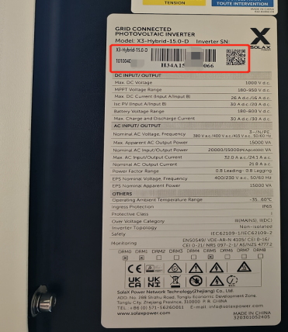
2.[Photo]Local grid phase and line voltage.

3.[Photo]Inverter safety settings.
4.[Photo]The overvoltage protection values.


